**SENTIMENT ANALYSIS FOR MARKETING**

TEAM LEADER **:** JANANII.P

REGISTER NUMBER : 211521106065

NM ID : au211521106065

PHASE-4: DEVELOPMENT PART – 2

TOPIC: CONTINUE BUILDING THE SENTIMENT ANALYSIS SOLUTION MODULE : **Employing NLP techniques Generating insights.**

**INTRODUCTION:**

Sentiment analysis for marketing is the use of natural language processing (NLP) techniques to extract and analyze the sentiment of text data related to a product, service, or brand. This can be done on social media posts, customer reviews, product descriptions, and other forms of text data.

Sentiment analysis can be used to gain insights into customer satisfaction, identify trends in public opinion, and evaluate the effectiveness of marketing campaigns. It can also be used to identify influencers, track competitor activity, and prevent PR crises.

NLP techniques for sentiment analysis

There are a variety of NLP techniques that can be used for sentiment analysis. Some of the most common include:

* Lexicon-based sentiment analysis: This approach uses a dictionary of words and phrases that have been assigned a sentiment score (e.g., positive, negative, neutral). The sentiment score of a text is calculated by summing the sentiment scores of the individual words and phrases in the text.
* Machine learning-based sentiment analysis: This approach uses machine learning algorithms to train a model to classify text as positive, negative, or neutral. The model is trained on a dataset of labeled examples, where each example is a piece of text that has been manually labeled with its sentiment.

Generating insights with sentiment analysis

Once you have performed sentiment analysis on your text data, you can use the insights you have gained to improve your marketing strategy. For example, you could:

* Identify areas where customers are unhappy: This information can be used to improve your products, services, or customer support.
* Track customer satisfaction over time: This can help you to identify trends and measure the impact of your marketing campaigns.
* Identify influencers: You can reach out to influencers and partner with them to promote your products or services.
* Track competitor activity: You can use sentiment analysis to track how customers feel about your competitors' products and services. This information can be used to develop competitive advantages.
* Prevent PR crises: You can use sentiment analysis to identify negative sentiment about your brand or products early on. This allows you to take action to address the issue before it becomes a major PR crisis.

Examples of sentiment analysis in marketing

Here are a few examples of how sentiment analysis can be used in marketing:

* A company that sells shoes could use sentiment analysis to analyze customer reviews on its website. This information could be used to identify areas where customers are unhappy with the products (e.g., sizing, comfort, durability). The company could then use this information to improve its products.
* A company that launches a new marketing campaign could use sentiment analysis to track customer sentiment over time. This information could be used to measure the effectiveness of the campaign and identify areas where it could be improved.
* A company that wants to identify influencers in the fitness industry could use sentiment analysis to analyze social media posts. This information could be used to identify individuals who are creating positive content about fitness and have a large following. The company could then reach out to these individuals and partner with them to promote its products.
* A company that wants to track how customers feel about its competitors' products could use sentiment analysis to analyze customer reviews on social media. This information could be used to identify areas where the company's products have a competitive advantage.
* A company that wants to prevent PR crises could use sentiment analysis to identify negative sentiment about its brand or products early on. This information could be used to address the issue before it becomes a major PR crisis.

Conclusion

Sentiment analysis is a powerful tool that can be used to gain insights into customer sentiment and improve marketing strategies. By using NLP techniques to analyze text data, businesses can identify areas where they can improve their products, services, and marketing campaigns.

**OVERVIEW OF THE PROCESS:**

**The sentiment analysis process can be broken down into the following steps:**

1. Data collection: Collect the text data that you want to analyze. This could include social media posts, customer reviews, product descriptions, or any other form of text data that is relevant to your product, service, or brand.
2. Data preprocessing: Clean and prepare the text data for analysis. This may involve removing stop words, stemming or lemmatizing words, and correcting spelling errors.
3. Feature extraction: Extract features from the text data that are relevant to sentiment analysis. This may include features such as the words used in the text, the order of the words, and the presence of certain punctuation marks.
4. Sentiment classification: Use a machine learning algorithm to classify the text data as positive, negative, or neutral.
5. Results analysis: Analyze the results of the sentiment classification to identify insights into customer sentiment.

**Step-by-step procedure for sentiment analysis for marketing**

1. Identify the data sources that you want to analyze. This could include social media platforms, customer review websites, or your own website.
2. Collect the data from the identified sources. This can be done manually or using an automated tool.
3. Clean and prepare the data for analysis. This may involve removing stop words, stemming or lemmatizing words, and correcting spelling errors.
4. Choose a sentiment analysis tool. There are a number of different sentiment analysis tools available, both free and paid.
5. Configure the sentiment analysis tool. This may involve specifying the language of the data, the features to be extracted, and the sentiment classification algorithm to be used.
6. Run the sentiment analysis tool. This will generate a report that shows the sentiment of the data, classified as positive, negative, or neutral.
7. Analyze the results of the sentiment analysis. Look for patterns and trends in the data. Identify areas where customers are unhappy and where you can improve.

Here are some tips for using sentiment analysis for marketing:

* Use a variety of data sources to get a more complete picture of customer sentiment.
* Clean and prepare the data carefully before performing sentiment analysis.
* Use a sentiment analysis tool that is appropriate for the type of data that you are analyzing.
* Configure the sentiment analysis tool carefully to get the most accurate results.
* Analyze the results of the sentiment analysis carefully to identify insights into customer sentiment.
* Use the insights that you have gained to improve your products, services, and marketing campaigns.
* **PROGRAM :**

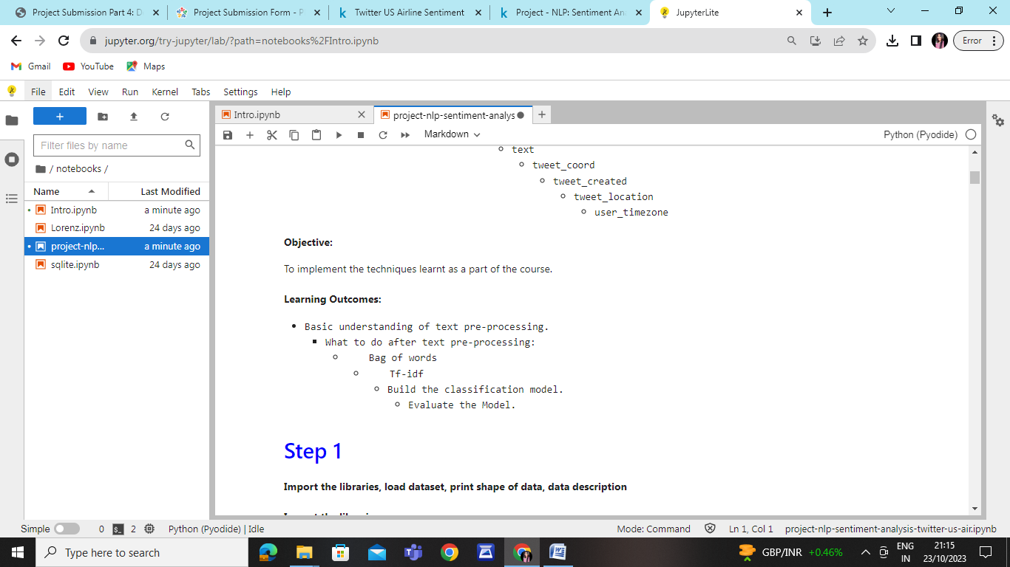

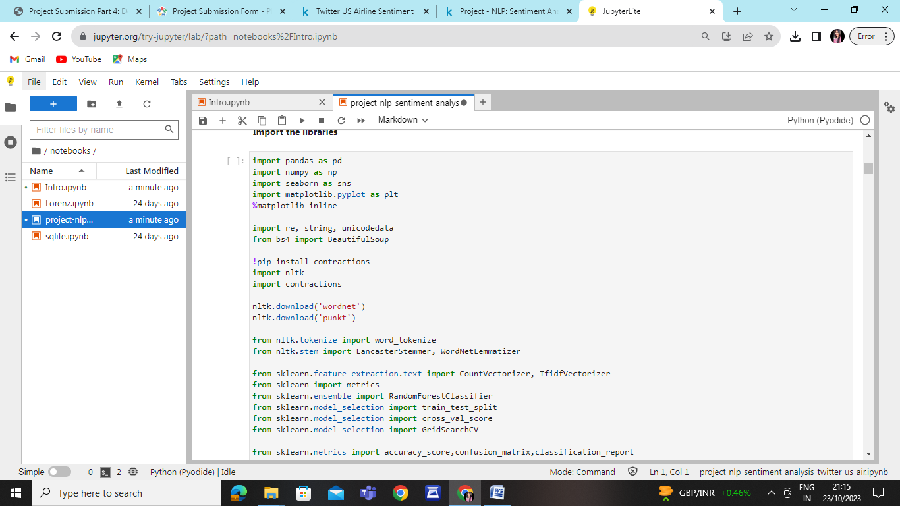

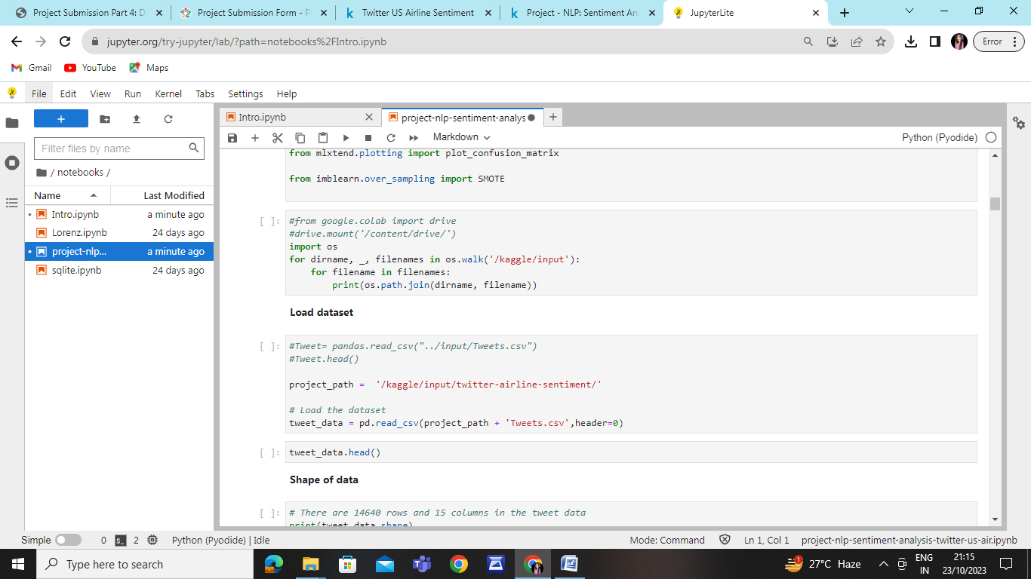

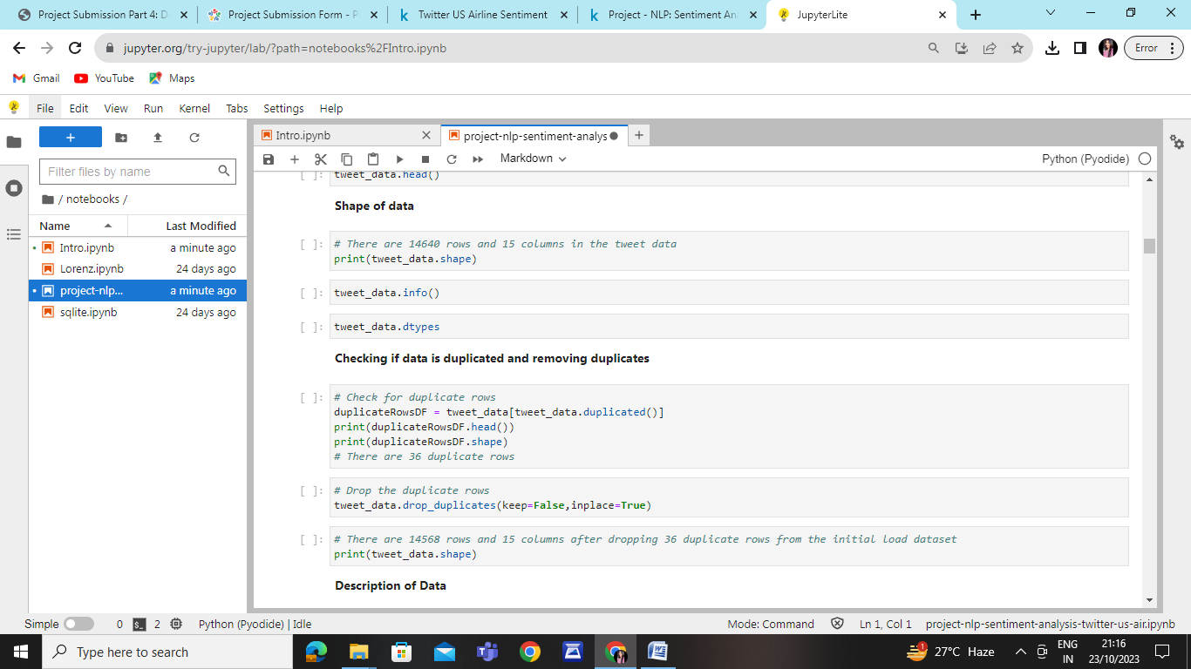

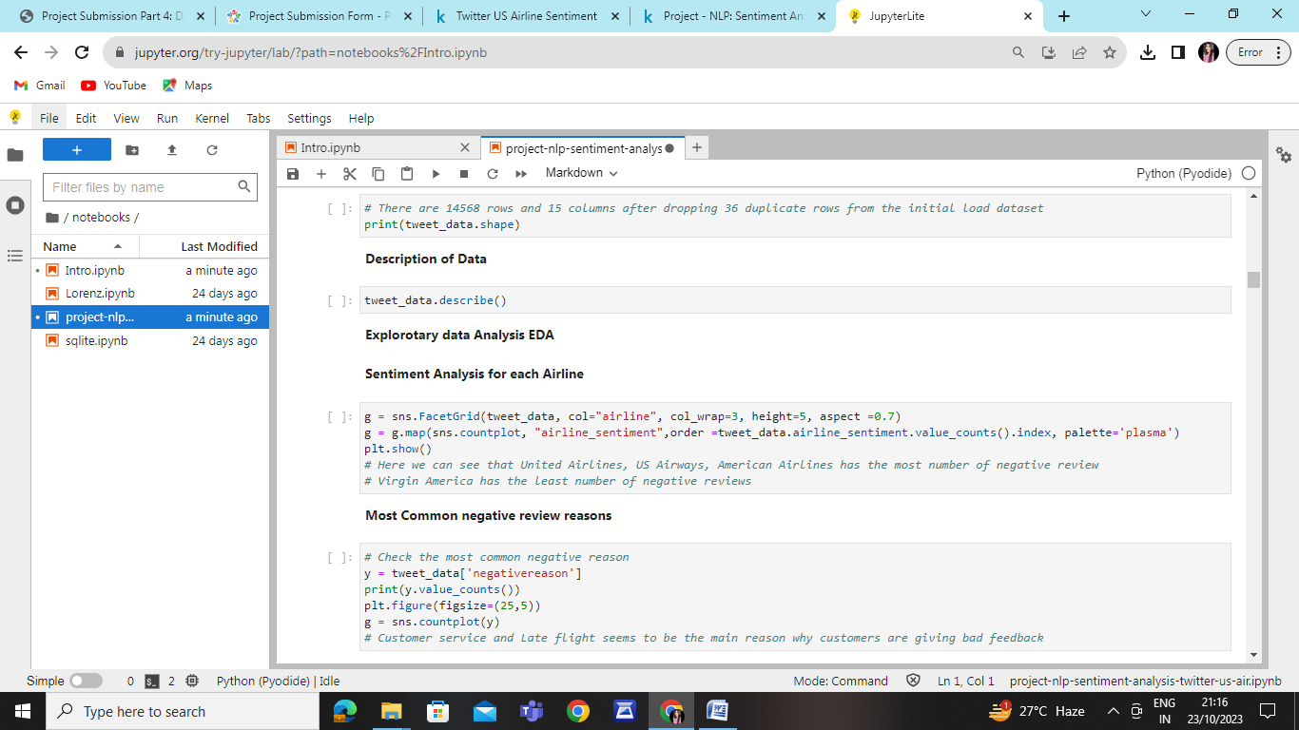

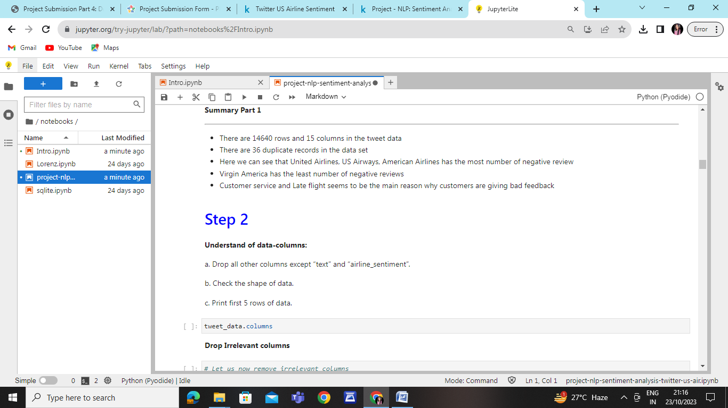

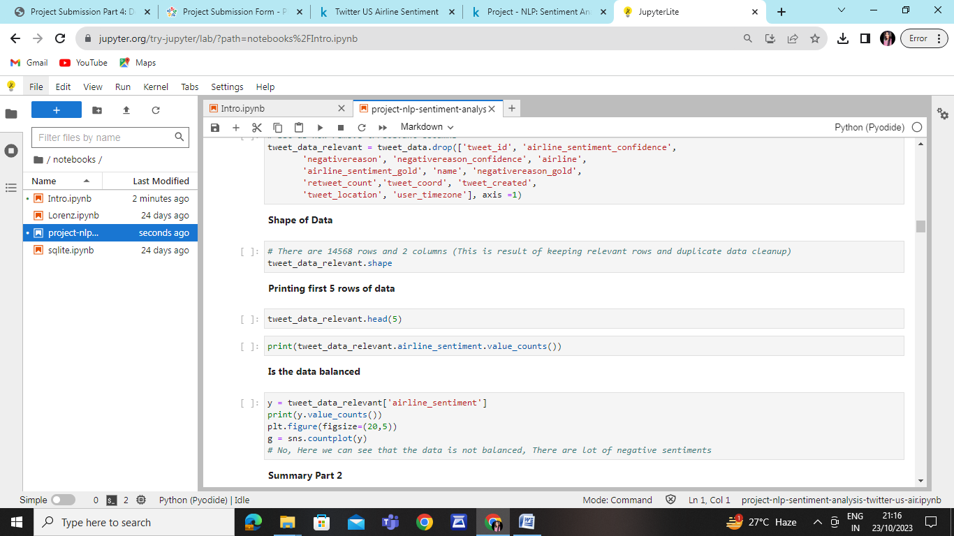

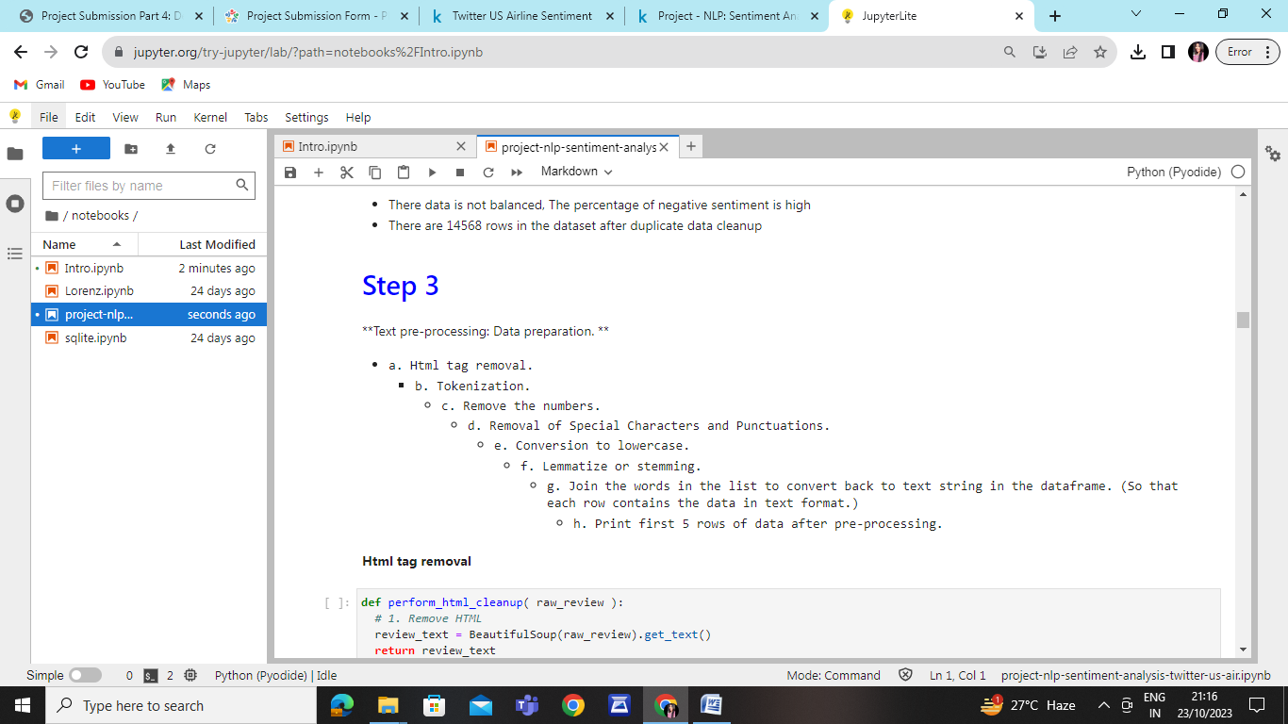



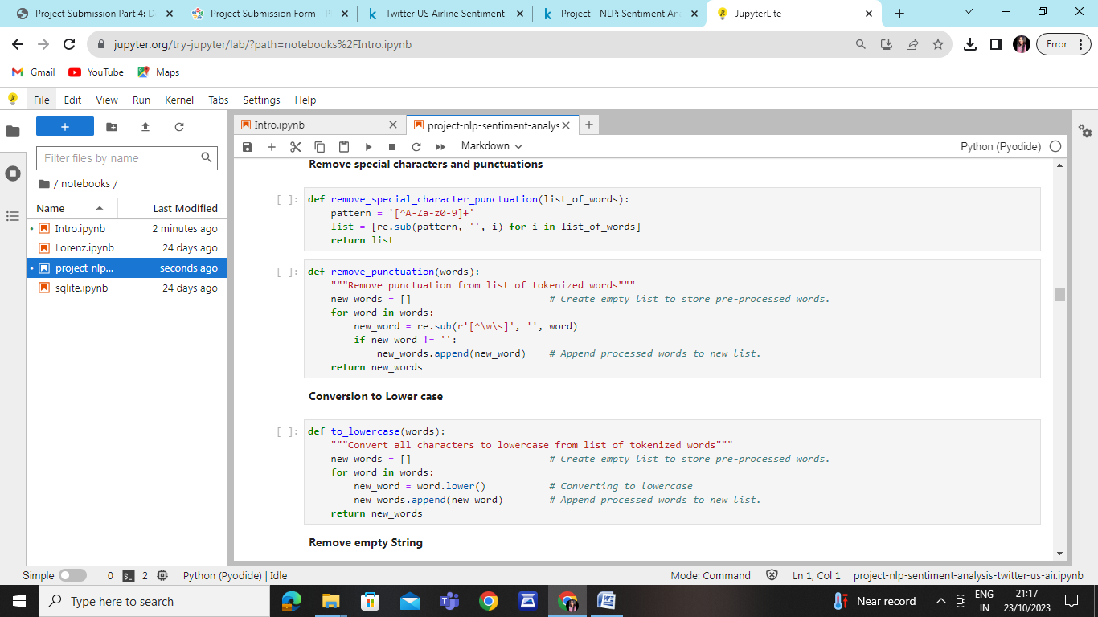

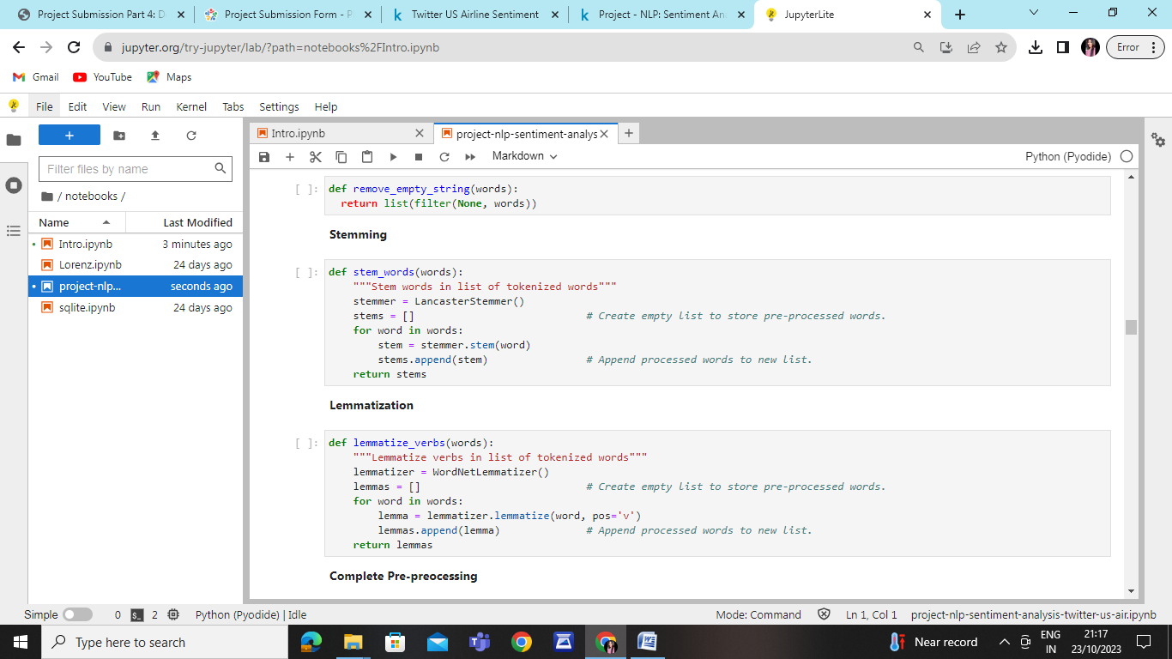

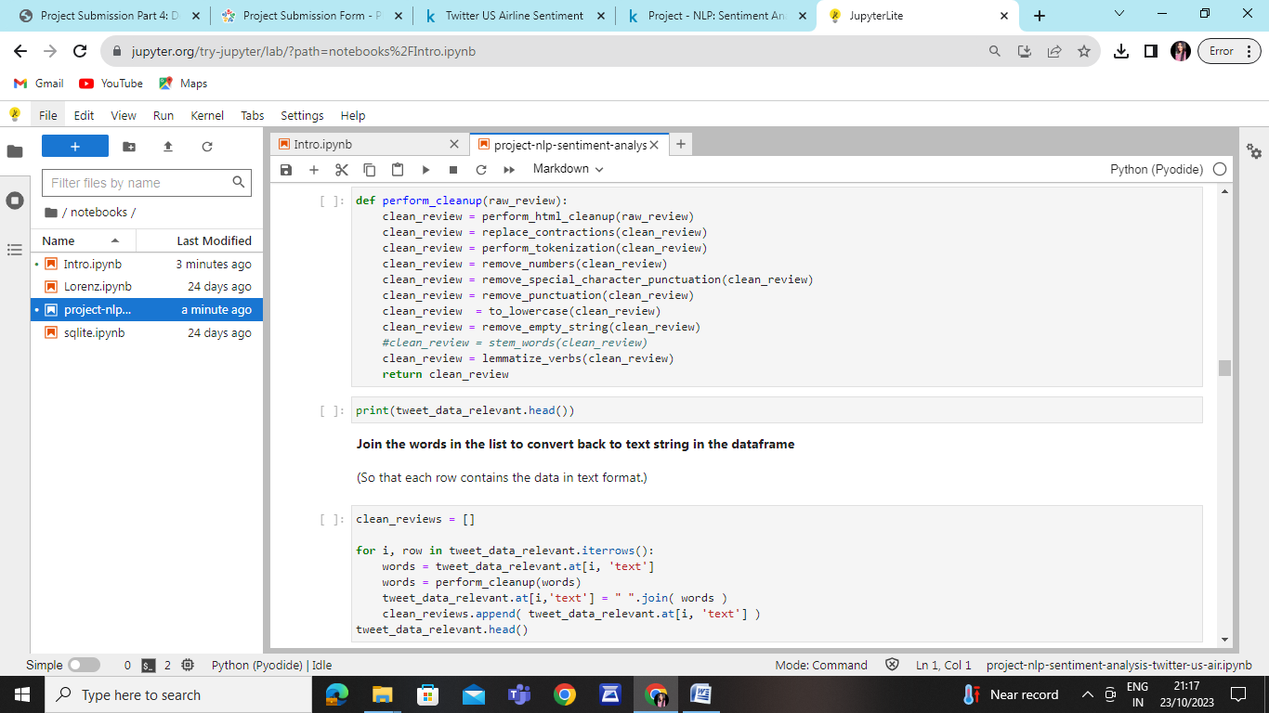

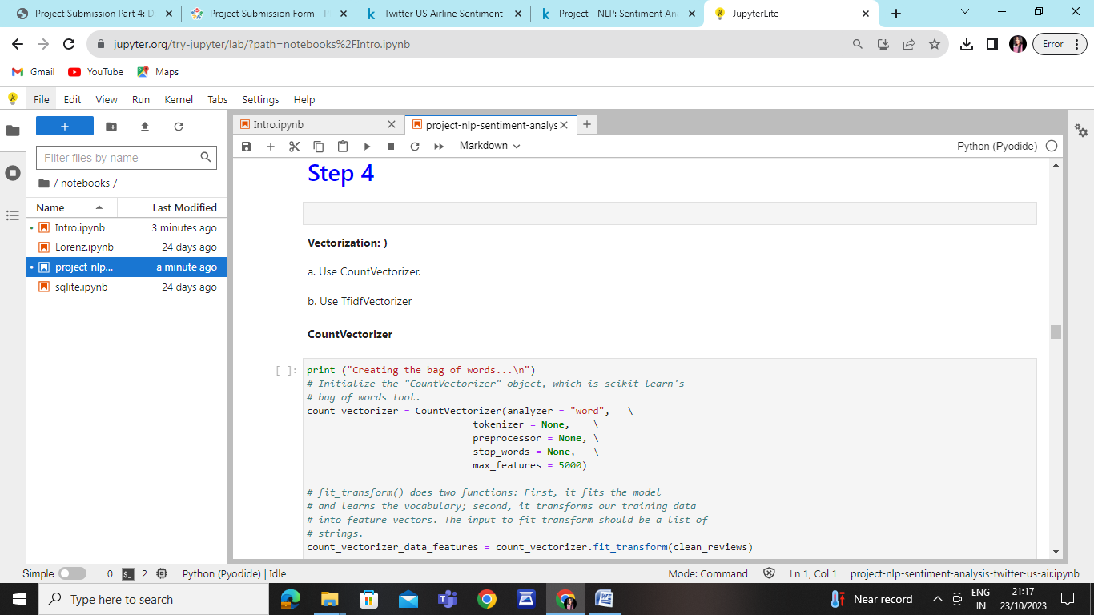

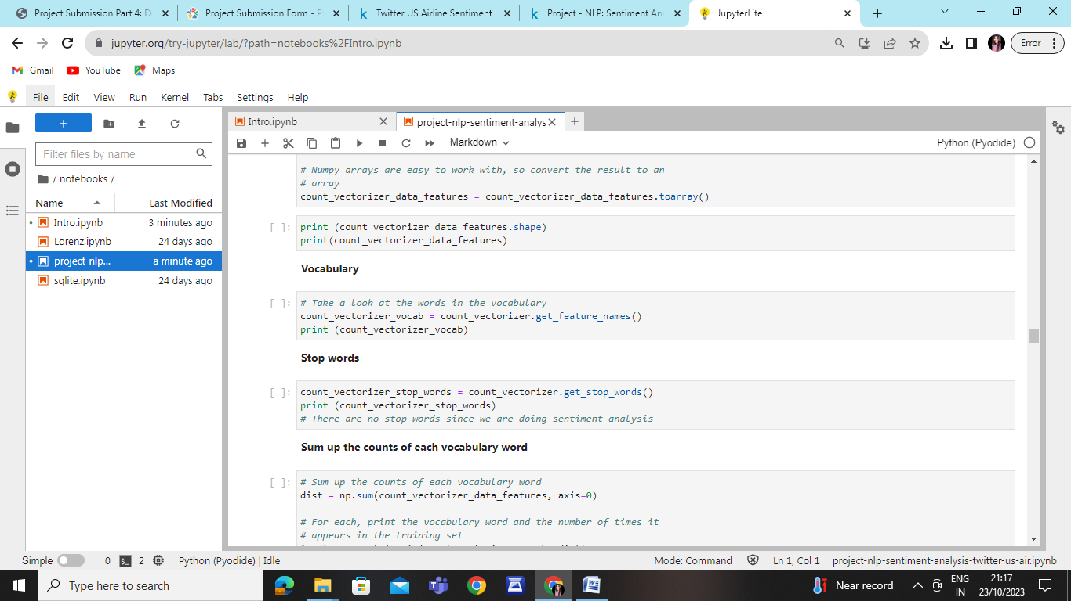

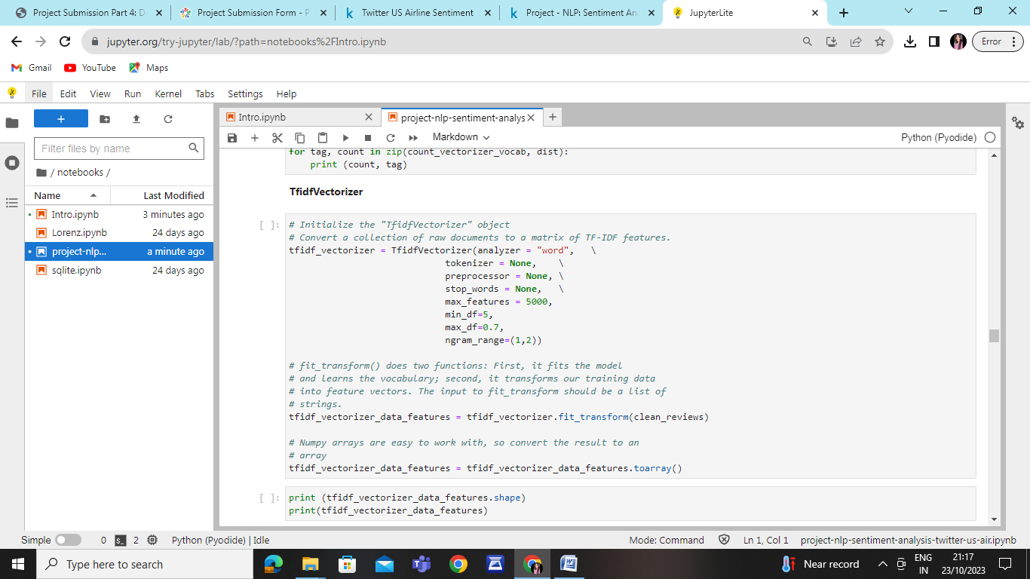

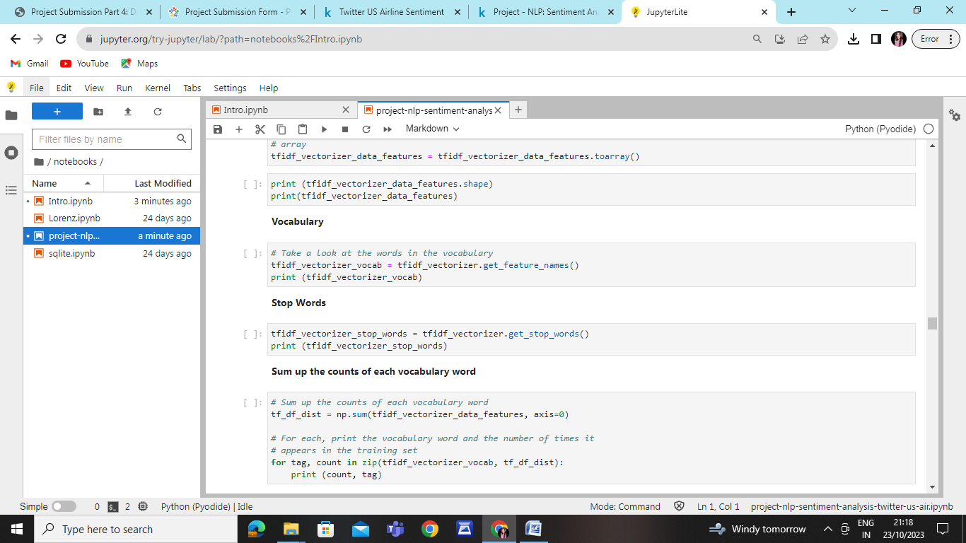

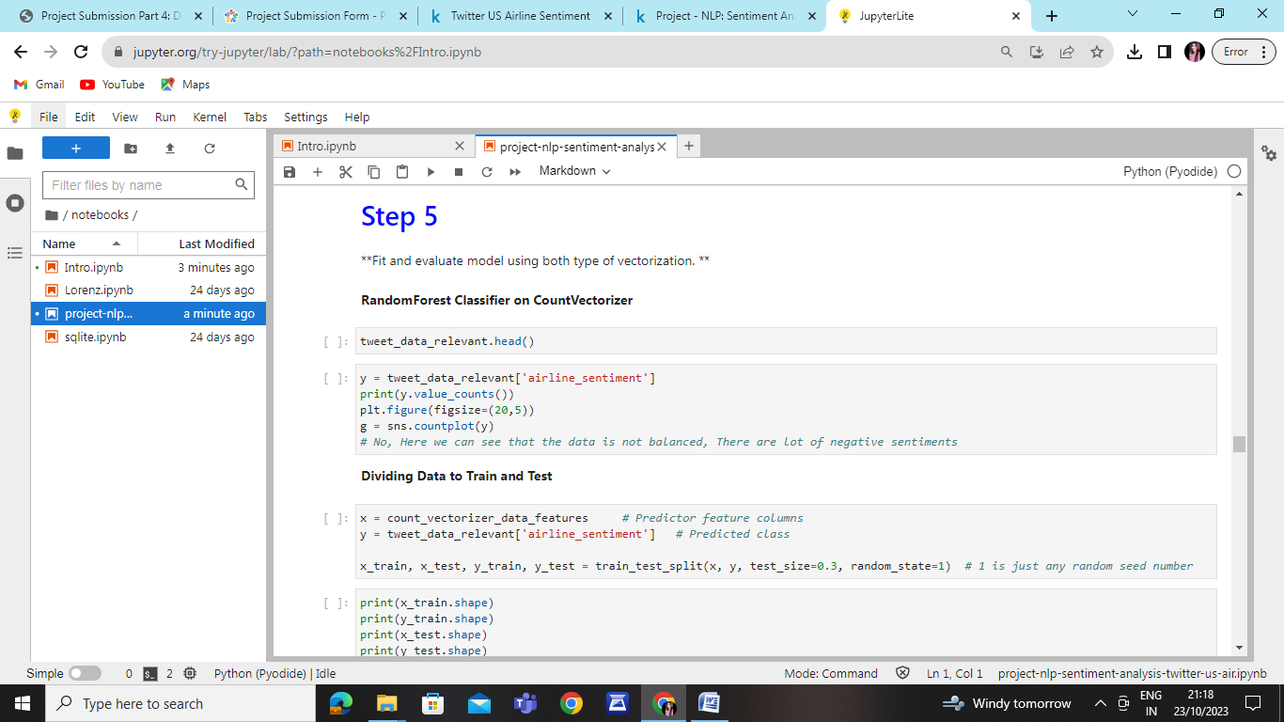

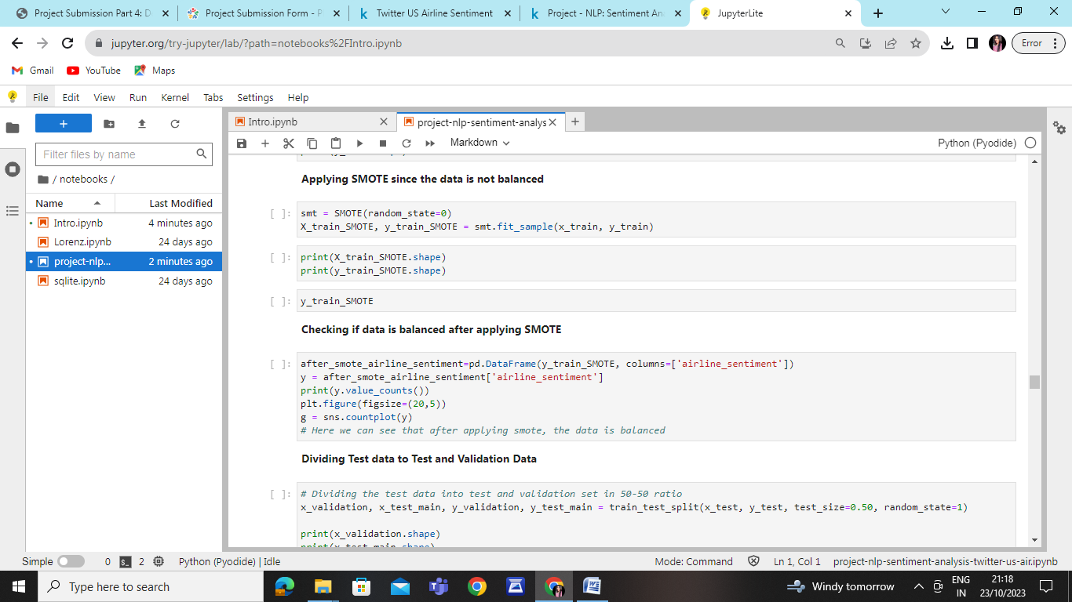

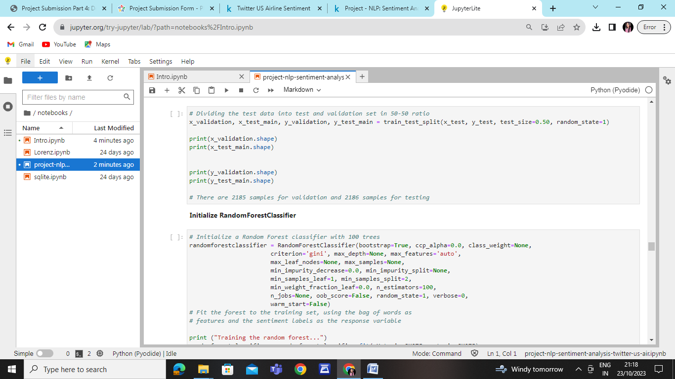

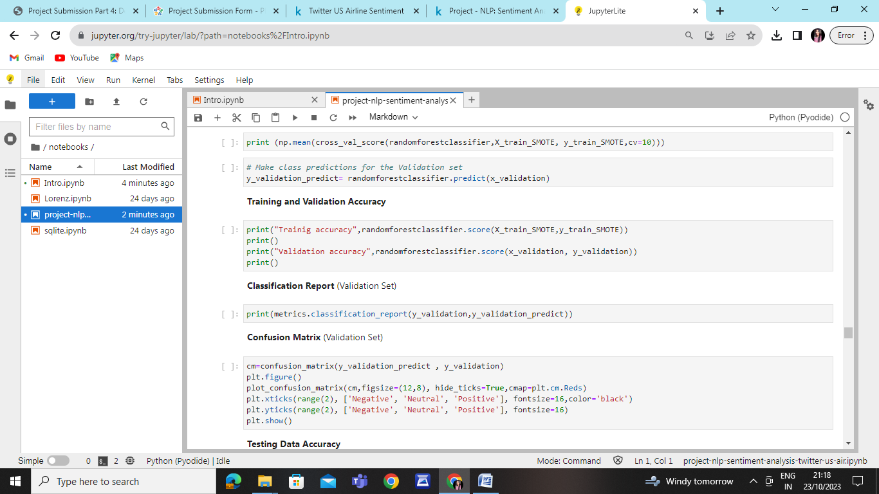

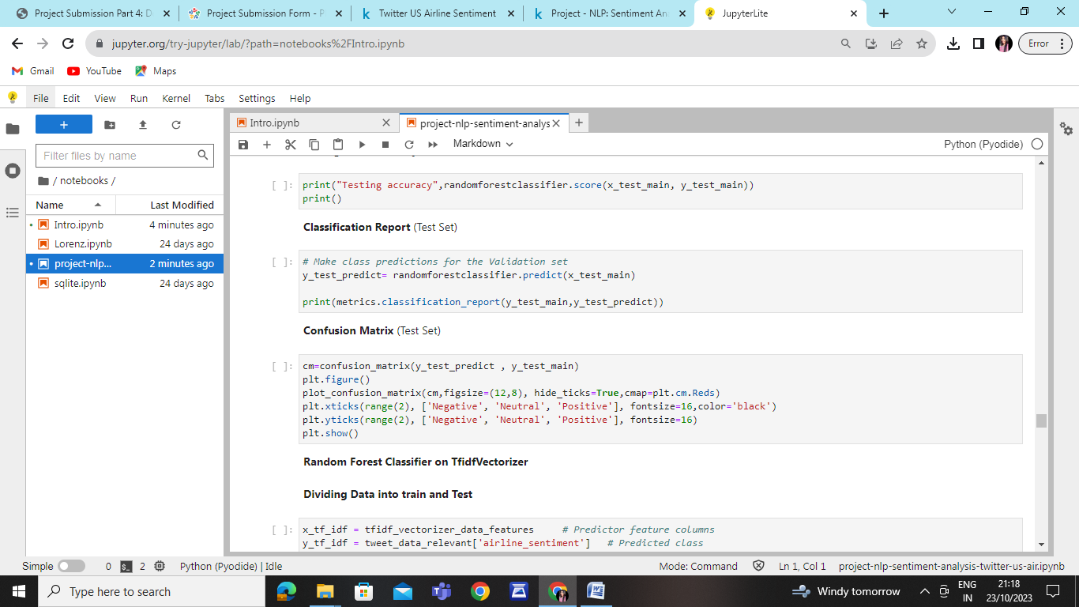

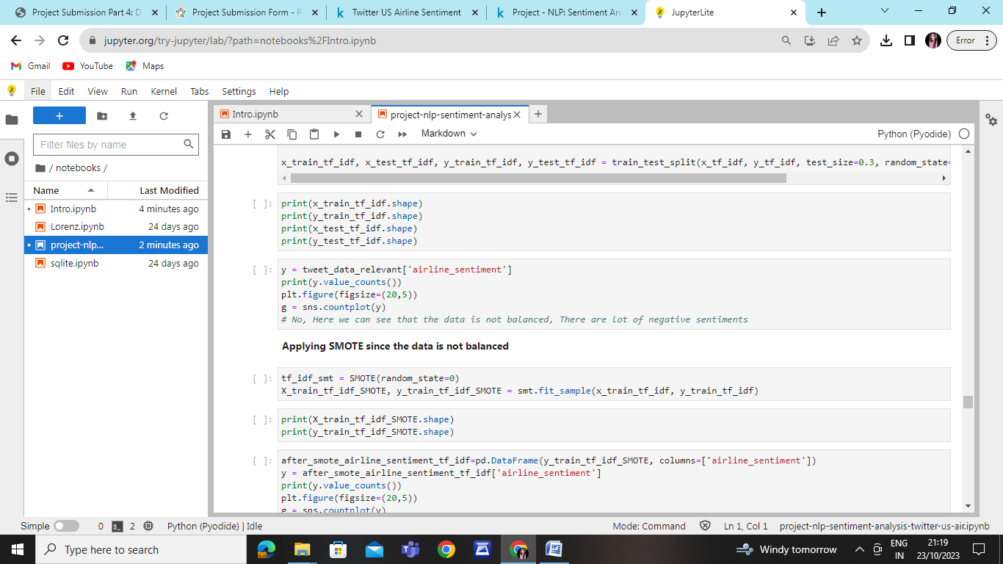

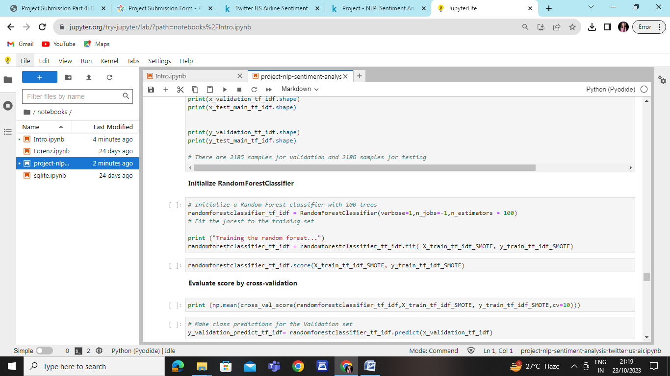

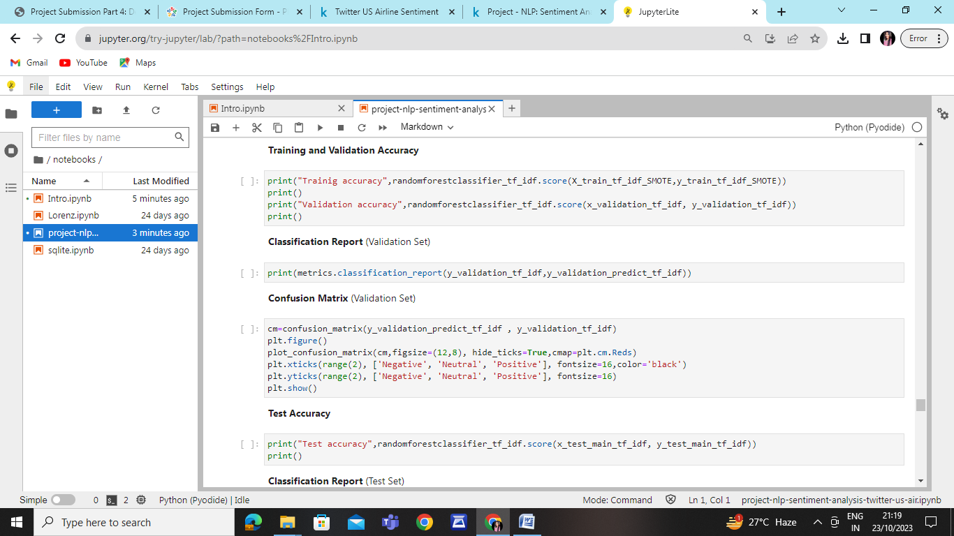

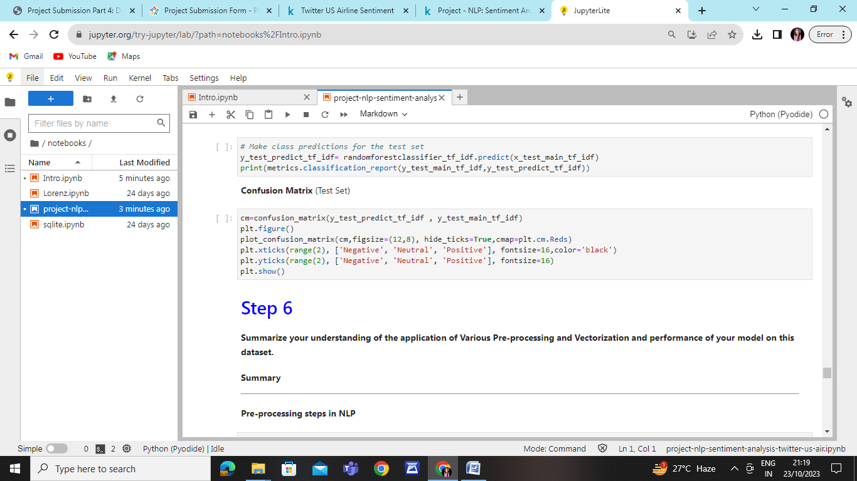

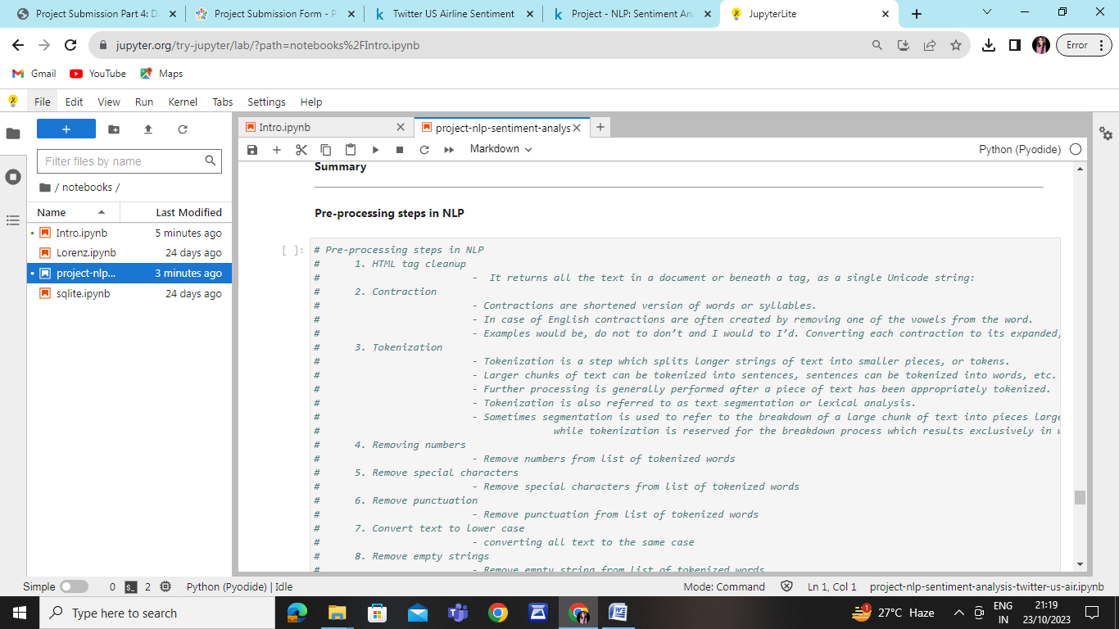

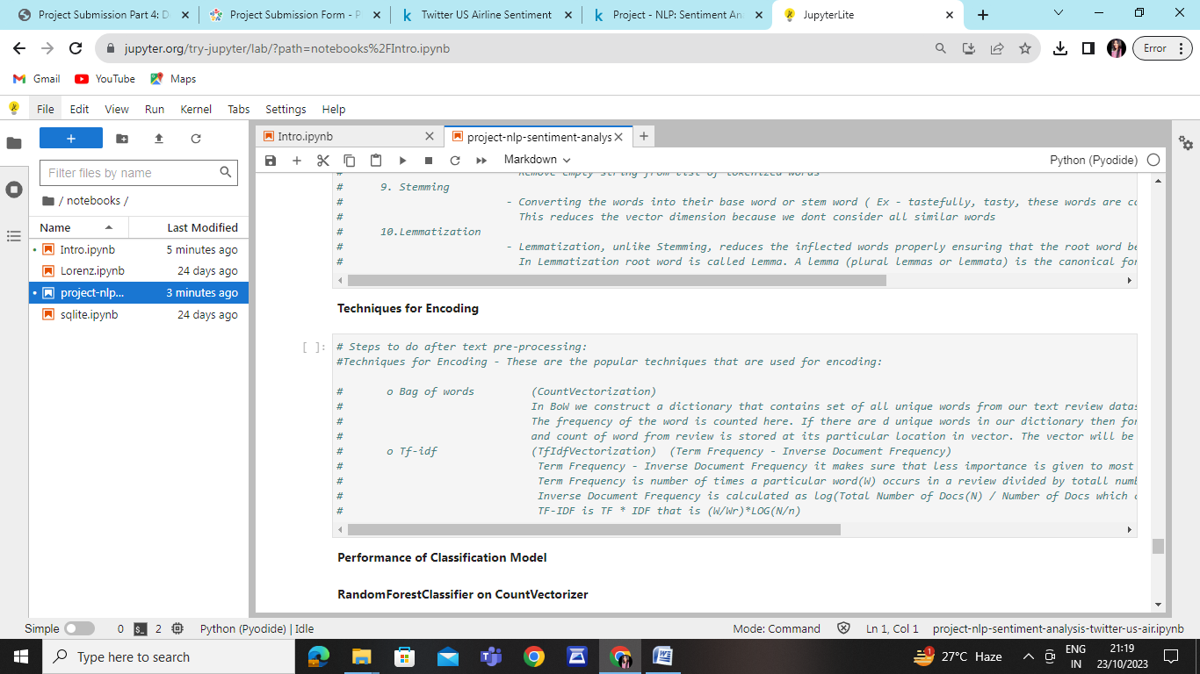

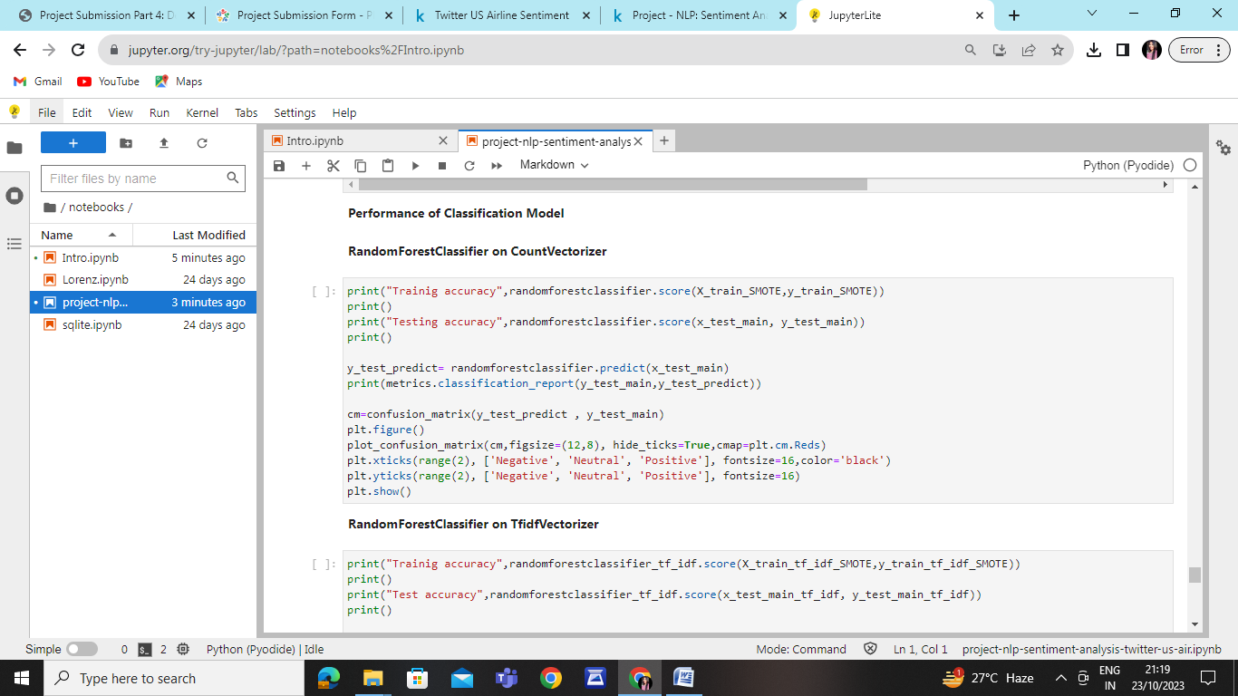

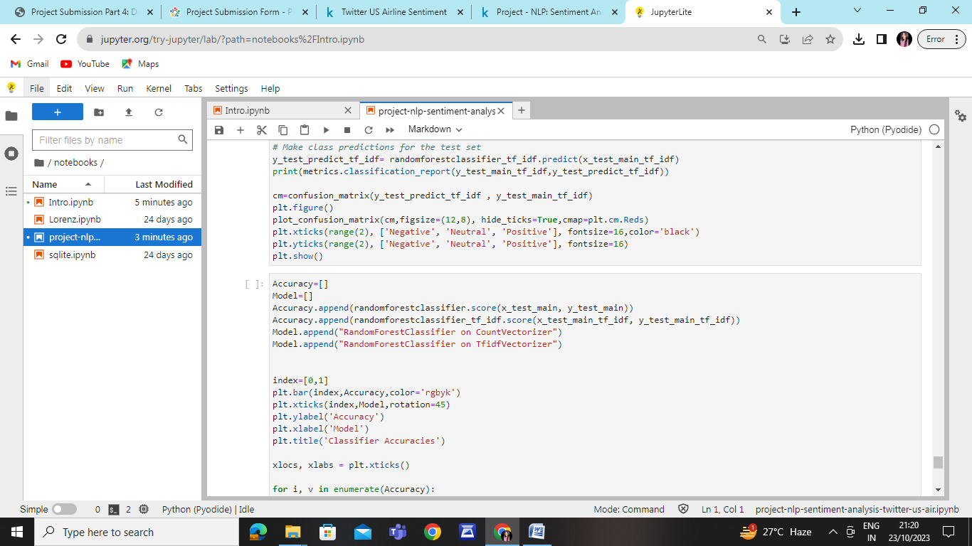

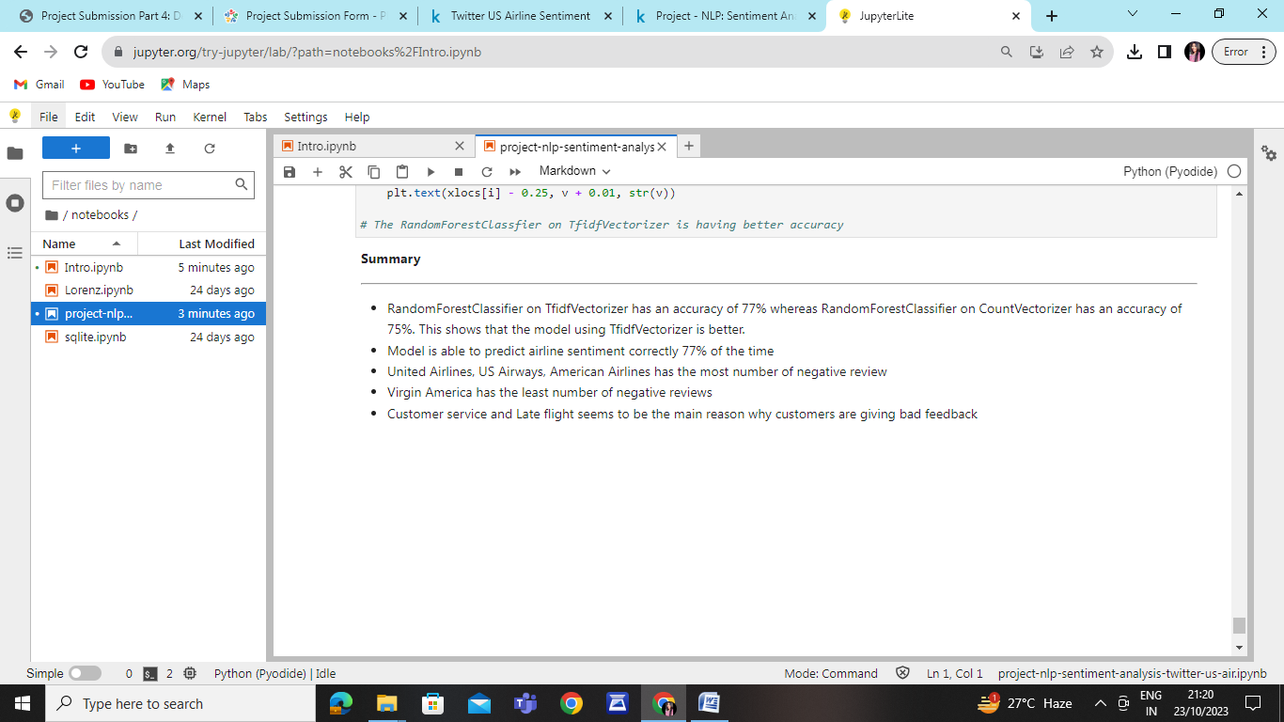

**CONCLUSION:**

**Accuracy on the rate of 67.86 % .**

**RUNTIME: 5.4 s**